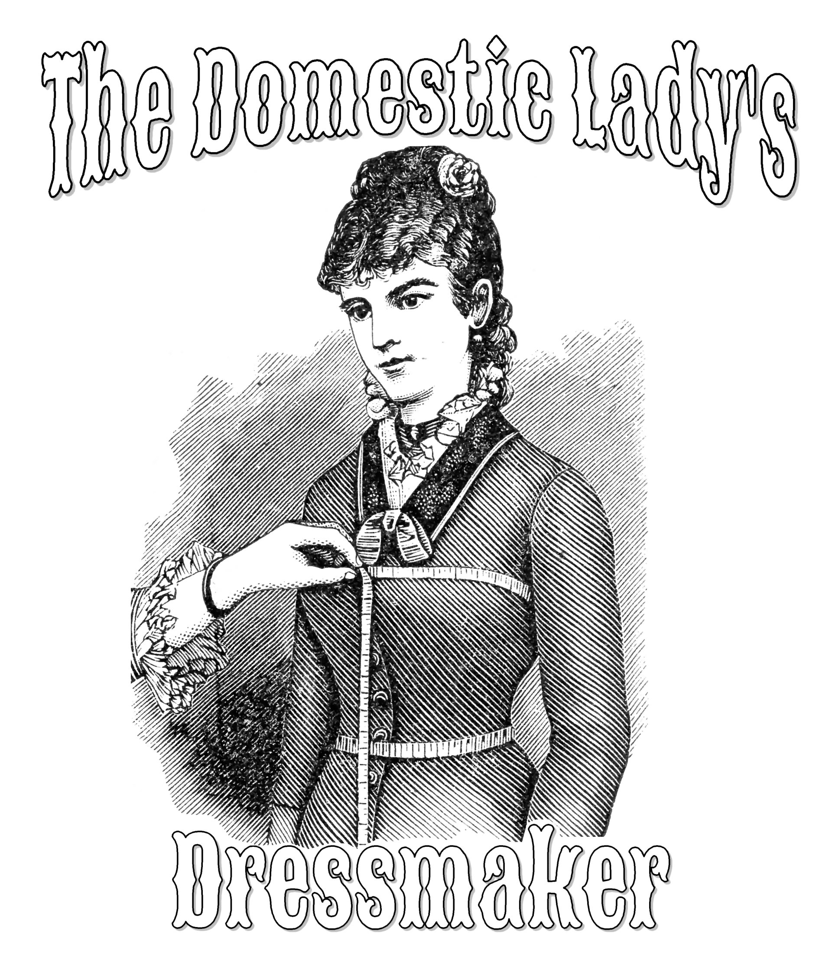
The Dressmakers (Virtual) Apprentice
Submissions close 9-4-20
Email to: marnadavis@gmail.com

A progressive apprenticeship in more ways than one, the goal is to teach you to be able to create appropriate clothing for a living history type situation. Then, as you complete projects, you will receive the next part of your “journey” toward a complete outfit. This dressmaker apprenticeship will get you started from the ground up and will focus on POST Civil War era (1868-1907). It is currently for U.S. only as I will be shipping items. Preference will be given to applicants who want to portray “working class” impressions as that is my specialty area of study. Finalists will be interviewed via zoom or other such video chat individually. I will choose ONE apprentice, but reserve the right to choose a back-up or second apprentice if I feel I need to or can afford to. This is a no-cost to the apprentice I choose.
What you can expect from me:
I will require garments are finished in a historic manner. Do not let this scare you, often there are reasons why things were done in a certain way. I know a lot of great “easy” ways to create working class clothing, and much of it can be completed on the sewing machine. Everything you need to complete your projects in a historically appropriate manner will be provided for you. I will expect you to follow my guidance on what is or is not historically correct. Photos of your completed pieces and your general progress along the way are expected. A reasonable timetable for completion of pieces will be created when I understand your other obligations.
You will be making your garments in this order. Each project must be completed before you receive the supplies for the next project. We will be working from patterns/directions I select for the timeframe you have stated you need. All pieces created will work together in a single timeframe to create a historically correct outfit.
1. Apron- basic waist apron with pocket.
2. Chemise and Drawers
3. Petticoat
4. Sunbonnet
5. Corded Corset
6. Dress
Application for “The Dressmakers (Virtual) Apprentice”
Name:
Address:
City: State: Zip code:
Email:
Phone number:
- I would have a hard time financially putting together an appropriate kit (complete costume) without this apprenticeship ( ) yes ( ) no

- I have a sewing machine available. (I just need to know what to expect, this will not take you out of the running if you say no.) ( ) yes ( ) no

- I have a Facebook account or am willing to have one. (This lets me know how I will have to set things up for communication.) ( ) yes ( ) no

- Previous Sewing experience Mark all that apply ( ) None ( ) Modern Clothes
( ) Crafts ( ) Quilting ( ) Home Ec or 4H ( ) I think I can thread a machine

- Any other personal information about yourself that you wish me to know.

- Why does an apprenticeship appeal to you?

- Do you have obligations that might cause you to not be able to complete your projects in a timely manner? (Going to school, working full time, etc. this can all be allowed for- I just need to know heading in what I can expect.)

- What museum/events are near you? Or where do you plan to use this outfit?

- What year do you want to portray (or range of years)?

- Why do you want to do living history?

- Do you have skills that would translate to historic trades or is there something you would like to learn to do? (For example: do you like to garden? cook? embroider? knit? spin? work with animals?)

- What is your favorite book in the history genre? Why?

